***CRM Web Application – AI Assisted Design***

# **The domain of the Project:**

# G5 - UIUX

# **Team Mentors (and their designation):**

# Sir Sen Ghiri Sudhan

# UI/UX Designer - MetricStream

# **Team Members:**

Ms. Trupti Zaware

# **Period of the project**

# **July 2025 to December 2025**

Declaration

The project titled “CRM Web Application – AI Assisted Design” has been mentored by Sir Sen Ghiri Sudhan, organised by SURE Trust, from July 2025 to December 2025, for the benefit of the educated unemployed rural youth for gaining hands-on experience in working on industry relevant projects that would take them closer to the prospective employer. I declare that to the best of my knowledge the members of the team mentioned below, have worked on it successfully and enhanced their practical knowledge in the domain.

Team Members:

Ms. Trupti Zaware

Signature

Mentor’s Name – Sir Sen Ghiri Sudhan

Designation- UI/UX Designer - MetricStream

Prof. Radhakumari

Executive Director & Founder

SURE Trust

Table of contents

1. Executive summary
2. Introduction
3. Project Objectives
4. Methodology & Results(Screenshots)
5. Learning & Reflection
6. Future Scope & Conclusion

***Executive Summary***

This project involves designing a CRM web application using AI-assisted tools. Lovable.dev was used to support ideation and layout generation.

***Introduction***

CRM systems are essential for managing leads and client relationships. The goal was to explore AI as a design assistant rather than a replacement.

***Project Objectives***

* Design a functional CRM system
* Use AI ethically in design workflow
* Maintain UX logic and clarity

***Methodology and Results***

**Process:  
Research → Flow Design → AI Prompting → UX Validation**

**AI Role:  
AI was used to generate layout ideas, while UX decisions were manually validated and refined.**

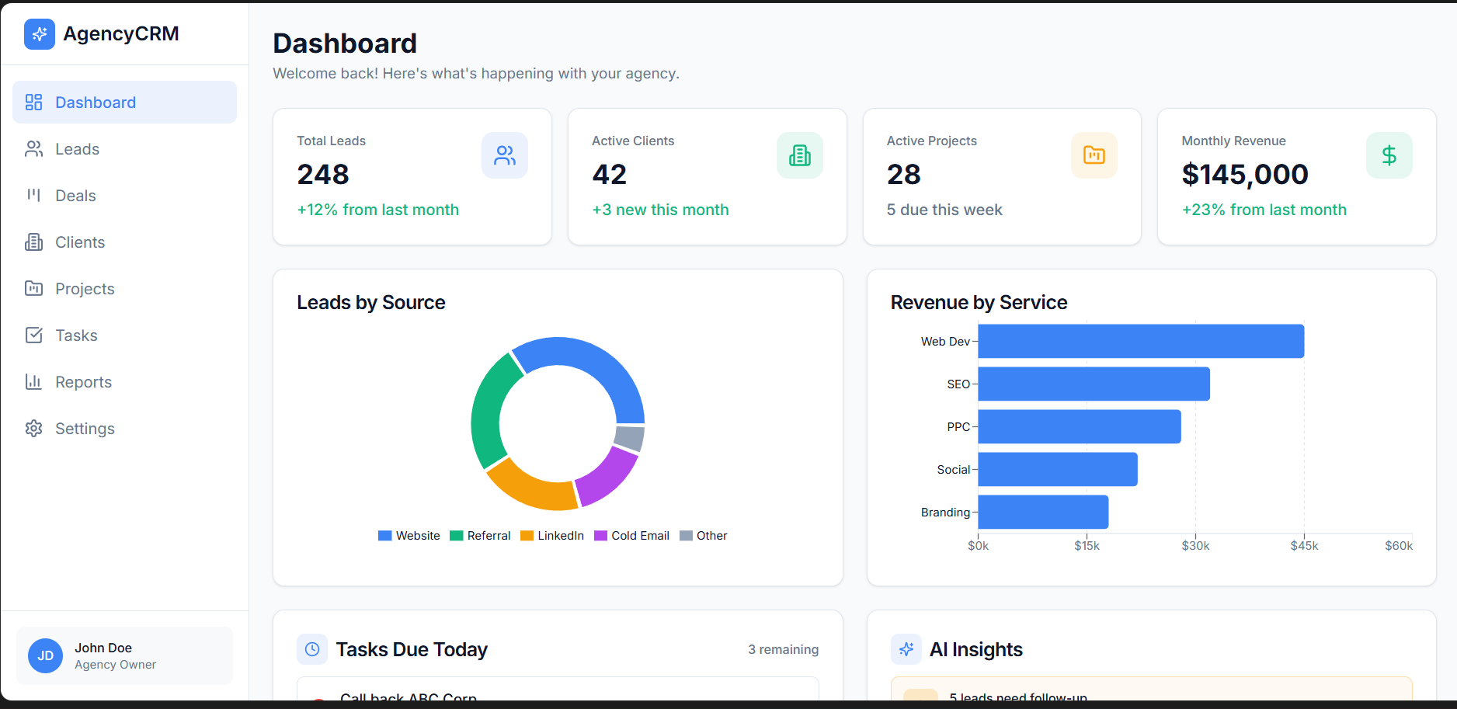

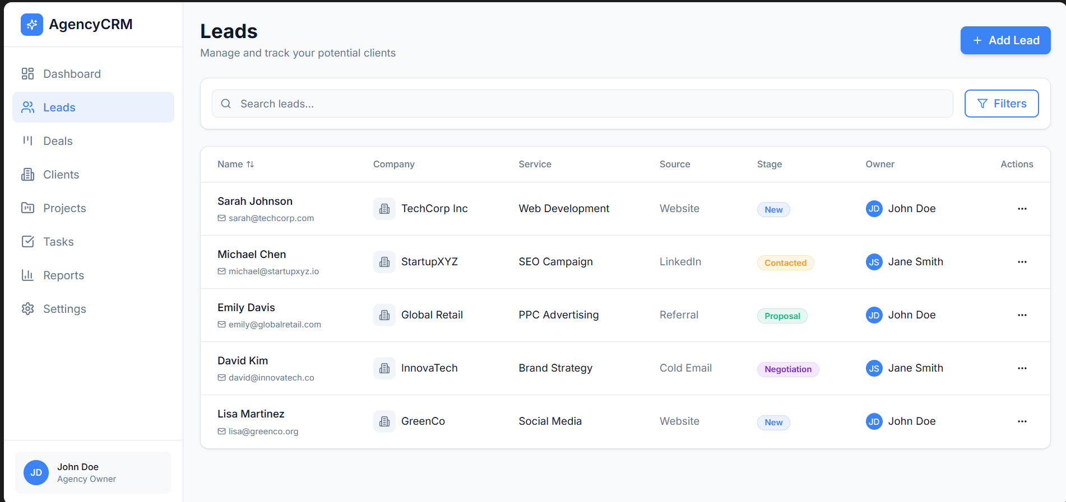

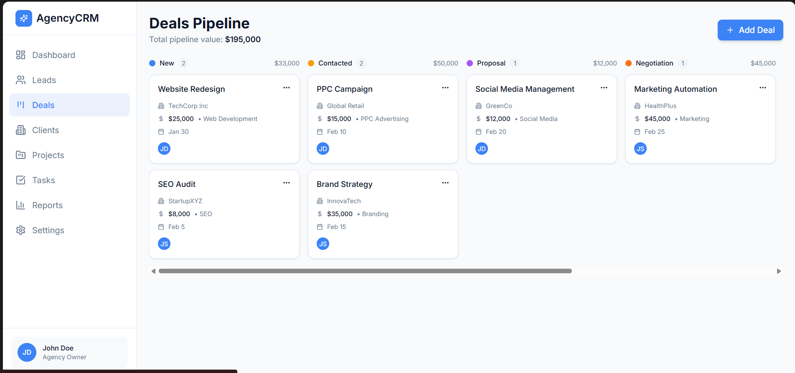

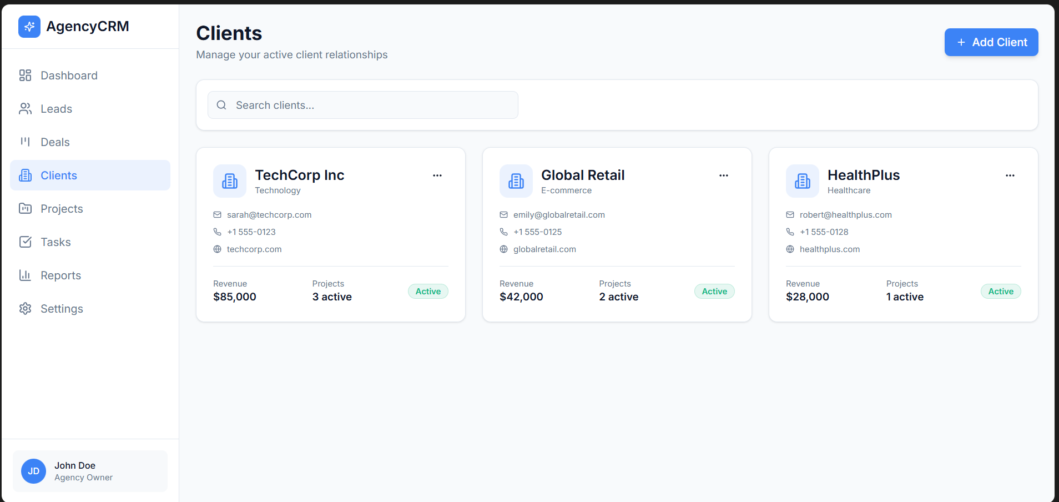

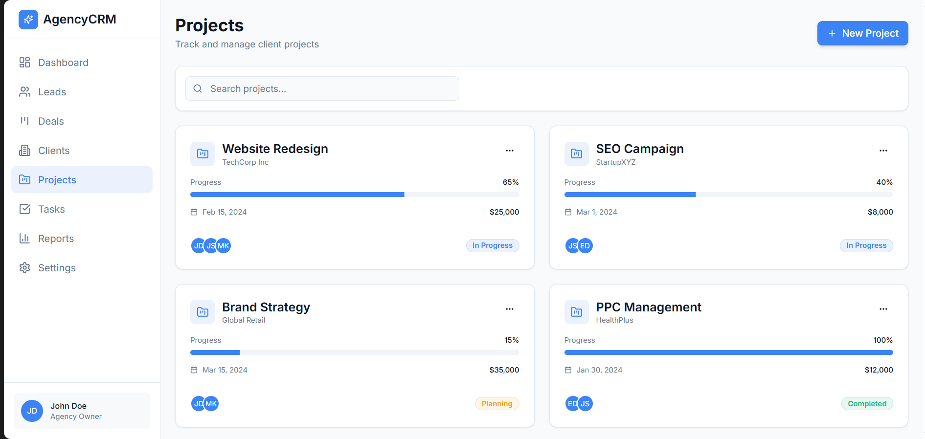

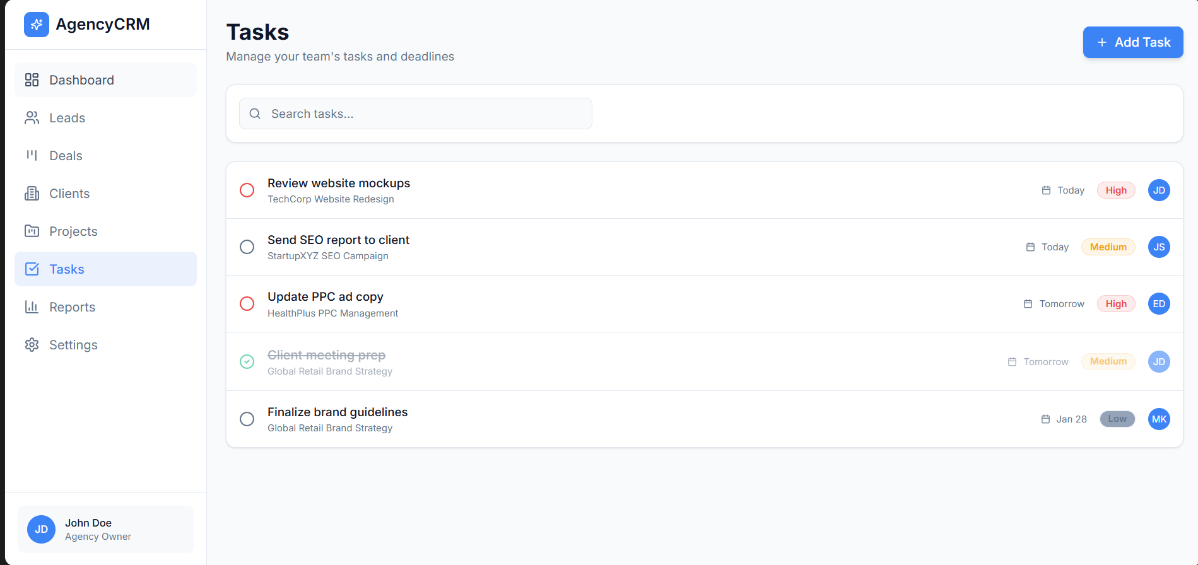

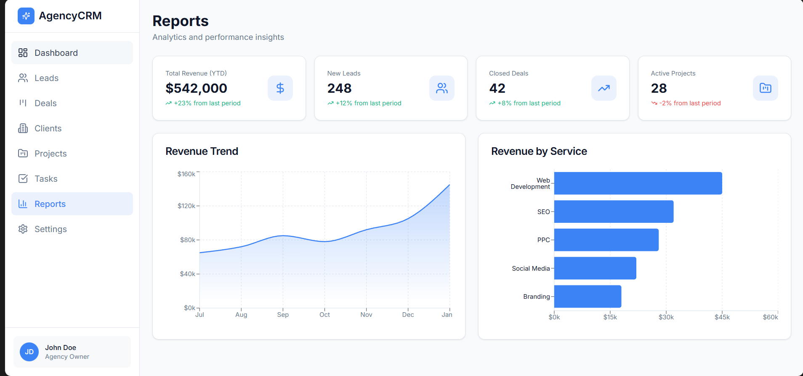

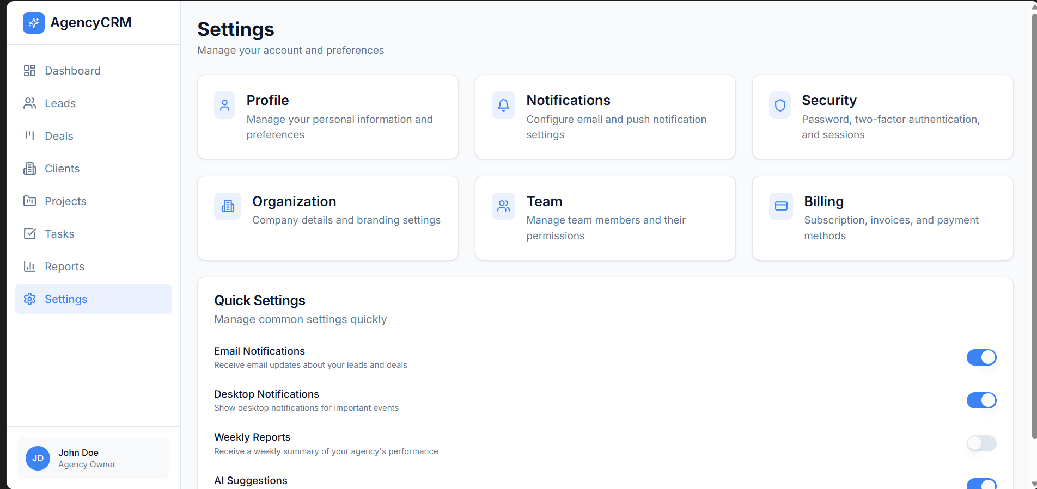

***Learning and Reflection***

Learned how to collaborate with AI tools while maintaining design responsibility.

***Conclusion and Future Scope***

Further customization and real data integration can enhance the CRM.